**Mid TEST for 7th grade**

**Name_____________________________________**

**1. Прочитайте текст. Для каждого предложения А–Е выберите один правильный вариант ответа из четырёх предложенных (1, 2, 3 или 4).**

Dear Ben,

How are you? I hope you are enjoying your holidays. Last weekend, I visited my cousin, Leo, who lives in a small town near the mountains. The place was beautiful, and the air was so fresh!

On Saturday morning, we went hiking. It was tiring but fun. After that, we had a picnic by the river. The food was delicious! My aunt made homemade sandwiches and fruit juice. In the evening, we watched a movie.

On Sunday, we went to a local museum. It was small, but very interesting. There was an exhibition about old trains. Leo and I took many pictures! I really enjoyed my weekend and hope to visit again soon.

What about you? What did you do last weekend? Write back soon!

Best wishes,  
Emma

**A. Where did Emma go last weekend?(Куда Эмма ходила в прошлый выходной?)**

1. To the seaside
2. To the mountains
3. To a big city
4. To another country

**B. What did Emma and Leo do on Saturday?(Что Эмма и Лео делают в субботу?)**

1. They visited a museum
2. They went shopping
3. They had a picnic
4. They rode old trains

**C. What did Emma say about the museum?(Что сказала Эмма о музее?)**

1. It was big and famous
2. It was small but interesting
3. It was boring
4. It was full of animals

**D. What did Emma enjoy the most?(Чем больше всего наслаждалась Эмма?)**

1. The fresh air
2. The sandwiches
3. The museum exhibition
4. The trip to the river

**E. Why does Emma ask Ben to write back?(Почему Эмма просит Бена написать?)**

1. She wants to visit him
2. She wants to know about his weekend
3. She wants to invite him to the mountains
4. She wants to tell him more stories

**3. Прочитайте текст и вставьте вместо каждого пропуска, обозначенного буквами А–Е, нужную грамматическую форму, выбрав её из четырёх предложенных вариантов (1, 2, 3 или 4).**

My Best Friend

I have a best friend, Lucy. We have known each other for **A**_____ years. She is a little **B**_____ than me, but we study in the same class. We always **C**_____ time together. Last weekend, we **D**_____ to the zoo. It was amazing! I think I **E**_____ a great friend.

1. many
2. much
3. few
4. several
5. younger
6. oldest
7. smaller
8. taller
9. spends
10. spending
11. spend
12. spent
13. go
14. went
15. gone
16. goes
17. has
18. have
19. had
20. having

**4. Вы получили электронное письмо. Ниже приведён отрывок из этого письма.**

From: Jack@mail.uk  
To: YourEmail@mail.ru  
Subject: Hobbies

Hi!

I started playing the guitar last month. It’s really fun! Do you play any musical instruments? What hobbies do you enjoy? When do you usually do your hobbies?

Write back soon!

Jack

**Напишите ему ответное письмо объёмом 80–90 слов, ответьте на три его вопроса. Оформите свой ответ в соответствии с правилами оформления письма. Не пишите адрес и дату. Не забудьте поблагодарить друга за полученное письмо.**

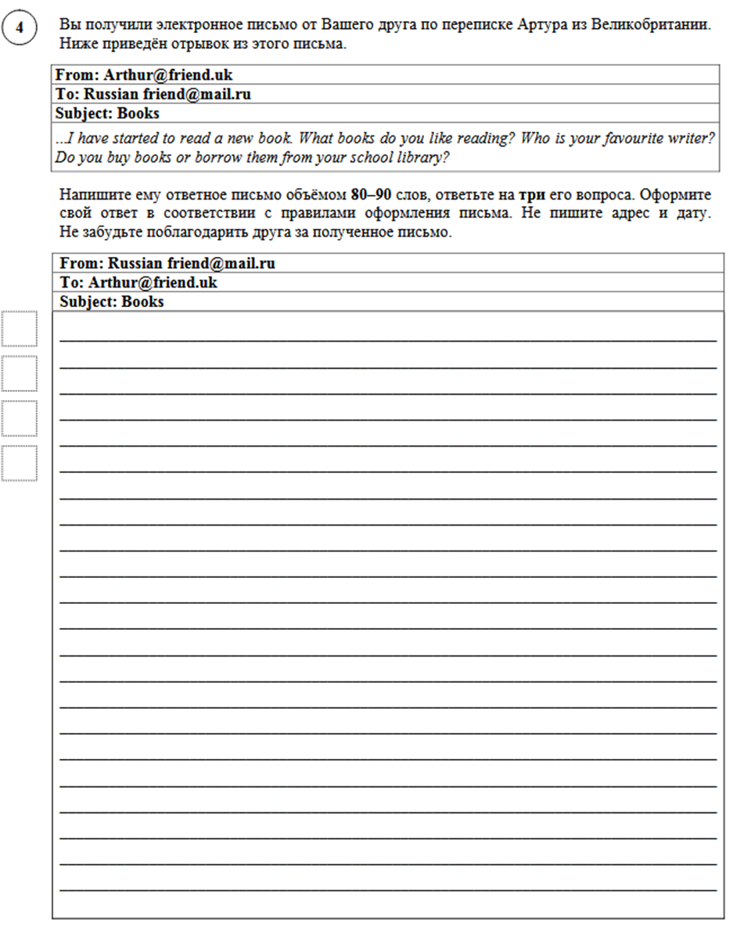

**Молодец! Спасибо за работу!!!**